***Love Jenga wooden puzzle game***

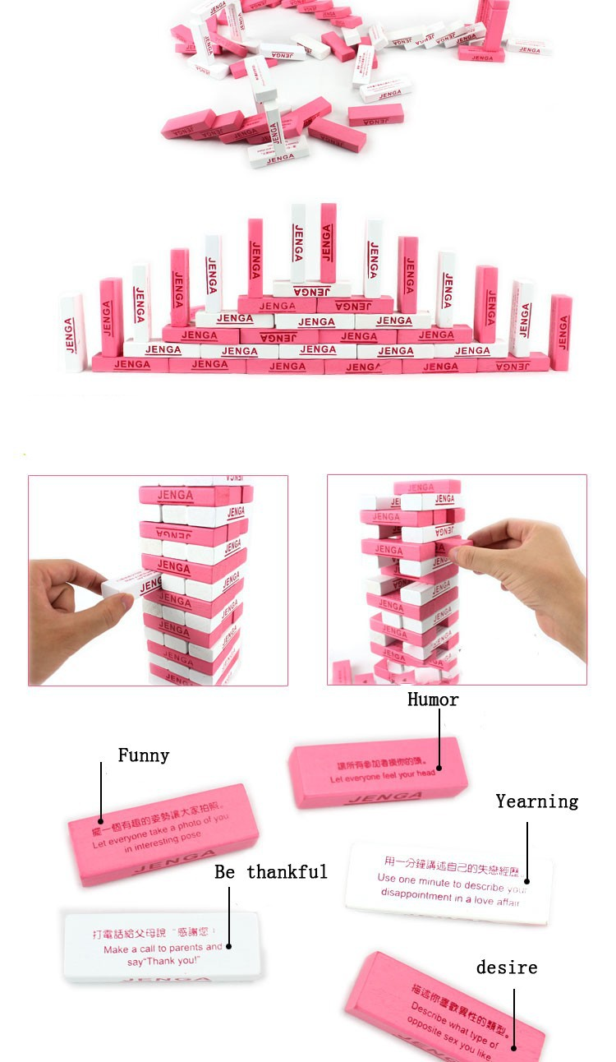

*Unique wooden draw toy set, this product is loved by many young people, usually in shops or snack shops or have these toys. Playing while drinking and talking is really interesting. Unlike the Wood Draw Game Set, which uses dice to play. The Love Jenga wooden draw set has a completely different way of playing. This wooden draw set has 54 bars, 27 pink bars and 27 white bars. Each Jenga wooden stick will have a command in English and Chinese. Players take turns drawing the wooden stick they like and then make a bridge on that wooden stick. This is a very interesting game to play with a group of friends and colleagues. Helps reduce stress and bring joy to the whole group. Birthday gifts.*